# **Business Analyst Assessment**

1. **Spreadsheets Assessment**

Context:

The role requires regular use of spreadsheets to build metrics to track a specific business objective. This is a small assignment to help us understand your ability to work with metrics using spreadsheets.

Click [here](https://docs.google.com/spreadsheets/d/1qazRR2_DVe5rrlt_KZrCMmdvN8jRDoCLt94cauGPvJE/edit?usp=sharing) to access the assignment.  
**Please make a copy of the Google Sheet and rename it as ‘<Your Name> - Crio Spreadsheet Assignment’. Please share edit access with everyone who has the link to the sheet.**

# **SQL Assessment**

## Context:

The role we are hiring for needs good SQL skills. Here is a small & fun assignment to help us understand your SQL skills.

You have to answer few questions based on the IPL data here - [Indian Premier league(IPL Cricket) till 2016 - dataset by raghu543 | data.world](https://data.world/raghu543/ipl-data-till-2016-set-of-csv-files).

Btw, you can sign in and launch workspace within the above link to write SQL queries directly there.

## **Questions:**

Write SQL queries for the following and share it in a doc or email:

1. Given a match id, print the player who scored the most number of runs.
2. Print 5 most economical bowlers across all matches.

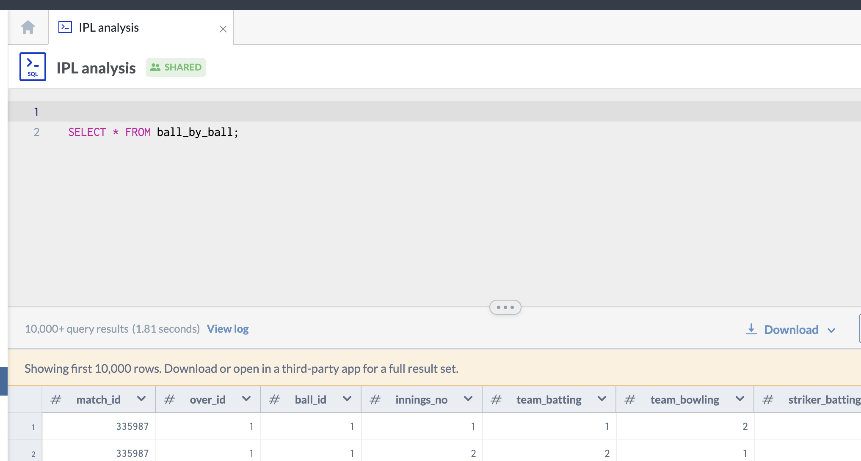

*Screenshot of the workspace interface on data.world*

## **IMPORTANT:**

## **ASSIGNMENT SUBMISSION LINK**

* Once your assignment is complete, add the doc and sheets link in a google drive folder ensure to have given view access to all, so we can view post submission
* Kindly add your google drive link and mention the link in this google form <https://forms.gle/dwYKJdguLT3jfMJp6>
* I.e. you can submit your assignment in this google form